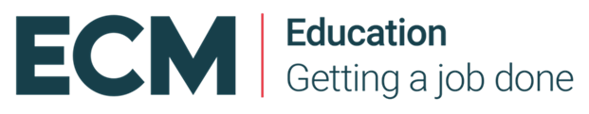
Audit and evaluate your curriculum, ready for the NEW Inspection Framework: Defining your curriculum Intent, Implementation and Impact

Using ECM tools breaking down Ofsted’s new inspection handbook and curriculum research you will audit and evaluate against the new curriculum agenda.

- Formulate the strengths and areas for development in your school’s intent implementation and impact.
- Define your intent: clearly outline what your curriculum is trying to achieve
- Clarify your implementation: consider your approaches to teaching, sequencing and progression of knowledge and skills that secures your intent;
- Know your impact: clearly define your desired outcomes from your curriculum, so that all children are ready for the next stage of their learning and achieve their aspirations;
- Draft your curriculum intent statement for your website
- Identify clearly your next steps for your curriculum.

Thursday 17th October 2019, 09:30 – 15:30
at World of Glass, St Helens, WA10 1BX
Course Leader: Ann Flannery

£175.00 + VAT per delegate

To book a place on this course, please email paula.foster@sthelens.org.uk

